Report
CO2_AT3 Assessment
Q22. Debugging Bubble Sort Code (Missing Early Termination Optimization)
1. Aim
To debug the given Bubble Sort program by introducing an early termination flag that stops unnecessary passes when the array becomes sorted.

2. Problem Statement
The given Bubble Sort implementation correctly sorts the array but continues executing all passes even after the array is already sorted. This results in unnecessary comparisons and reduced efficiency.
The objective is to optimize the algorithm using a flag-based termination mechanism and analyze its performance.

3. Existing Code
def bubble_sort(arr):
n = len(arr)
for i in range(n):
for j in range(0, n-i-1):
if arr[j] > arr[j+1]:
arr[j], arr[j+1] = arr[j+1], arr[j]
return arr

4. Identified Inefficiency
The algorithm always performs all passes, even when no swaps occur during a pass.
This causes:
- Unnecessary comparisons
- Increased execution time
- Poor performance on already sorted arrays

5. Optimization Technique
A Boolean flag (swapped) is introduced.
- Set swapped = False at the beginning of each pass.
- Whenever two elements are swapped, set swapped = True.
- If no swaps occur during a complete pass, the array is already sorted.
- Exit the loop immediately using break.

6. Algorithm
- Read the array.
- Repeat Bubble Sort passes.
- Initialize swapped as False.
- Compare adjacent elements.
- Swap if required.
- Set swapped=True whenever a swap occurs.
- If no swaps occur after a pass, terminate early.
- Print the sorted array.

7. Optimized Source Code
def bubble_sort(arr):
n = len(arr)

for i in range(n):

swapped = False

for j in range(0, n-i-1):

if arr[j] > arr[j+1]:

arr[j], arr[j+1] = arr[j+1], arr[j]

swapped = True

if not swapped:
break

return arr

arr = [64, 34, 25, 12, 22, 11, 90]

print("Original Array:", arr)

bubble_sort(arr)

print("Sorted Array :", arr)

8. Sample Output
Original Array: [64, 34, 25, 12, 22, 11, 90]

Sorted Array : [11, 12, 22, 25, 34, 64, 90]
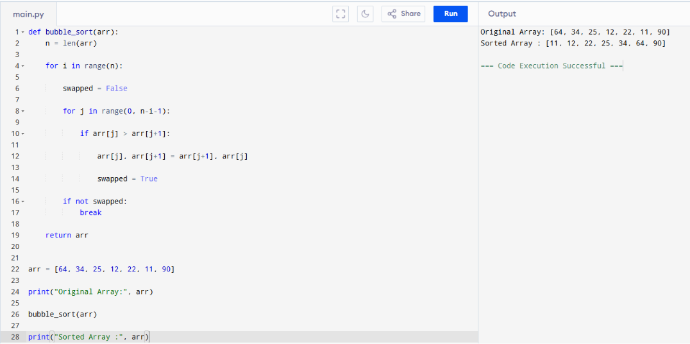
9. Analysis
The optimized Bubble Sort behaves exactly like the original version but stops immediately when the array becomes sorted.
Advantages:
- Eliminates unnecessary passes.
- Reduces execution time for sorted or nearly sorted arrays.
- Maintains the correctness of Bubble Sort.
- Improves practical performance without changing the sorting result.

10. Time Complexity Analysis
Case | Time Complexity
Best Case | O(n)
Average Case | O(n²)
Worst Case | O(n²)
Space Complexity
O(1)

11. Performance Improvement
Original Bubble Sort | Optimized Bubble Sort
Always performs all passes | Stops when sorted
More comparisons | Fewer comparisons
Slower on sorted arrays | Faster on sorted arrays
Time complexity (Best) = O(n²) | Time complexity (Best) = O(n)

12. Conclusion
The Bubble Sort algorithm was successfully optimized by introducing an early termination flag. The optimized version detects when the array is already sorted and exits immediately, avoiding unnecessary iterations. This significantly improves the best-case performance from O(n²) to O(n) while maintaining the same average and worst-case complexities of O(n²). The optimized implementation is more efficient, readable, and suitable for nearly sorted datasets.

